

VIETNAMESE STUDY SYSTEM FOR JAPANESE

Screen Design

**Project Code: Veazy**

**Document Code: Veazy_Screen_Design_v1.7**

**Ha Noi, 26/06/2016**

Record of change

*A - Added M - Modified D – Deleted

|  |  |  |  |  |
| --- | --- | --- | --- | --- |
| **Effective Date** | **Changed Items** | **A* M, D** | **Change Description** | **New Version** |
| 06/10/2016 | Screen design | A | Add screens | v1.0 |
| 06/30/2016 | Screen design | M | Update screens | v1.1 |
| 07/05/2016 | Screen design | M | Update screens | v1.2 |
| 07/25/2016 | Screen design | M | Update screens | v1.3 |
| 07/20/2016 | Screen design | M | Update screens | V1.4 |
| 08/01/2016 | Screen design | M | Update screens | V1.5 |
| 08/16/2016 | Screen design | M | Update screens | V1.6 |
| 08/23/2016 | Screen design | M | Update screens | V1.7 |

Table 1. Records of changes

**Signature page**

**Originator** Nguyen Hong Quan 26/06/2016

Developer

**Reviewer** Nguyen Trong Duy 23/08/2016

Developer

**Approval** Nguyen Van Sang 23/08/2016

Supervisor

Contents

1 Introduction 6

1.1 Purpose 6

1.2 Definitions, Acronyms and Abbreviations 6

1.3 Overview 7

2 Screen Flow 8

2.1 Guest 10

2.1.1 Homepage 10

2.1.2 Login 12

2.1.3 Password Recover 13

2.1.4 Register 14

2.1.5 Courses 15

2.1.6 Lesson 16

2.1.7 Test 18

2.1.8 Taking Test 20

2.1.9 Test Result 22

2.2 Logged-in user 23

2.2.1 User Profile 23

2.2.2 User Statistic 25

2.2.3 Test History 26

2.3 Content creator 26

2.3.1 Content Creator Dashboard 26

2.3.2 Lesson List 27

2.3.3 Lesson Detail 29

2.3.4 Adding Lesson 30

2.3.5 Editing Lesson 33

2.3.6 Question List 35

2.3.7 Question Detail 37

2.3.8 Adding Question 39

2.3.9 Editing Question 43

2.4 Admin 47

2.4.1 Admin Dashboard 47

2.4.2 Member List 47

2.4.3 System Statistic 48

3 Other considerations 49

# Introduction

## Purpose

The purpose of this document is to ensure the consistency as well as the simplicity in detailed design across all displays within Veazy interface. Screen design describes the process of designing layout and appearance of Veazy web page so that it is engaging to readers and easy to use.

## Definitions, Acronyms and Abbreviations

|  |  |  |
| --- | --- | --- |
| Abbreviations | Description | Comment |
| Veazy | Vietnamese Study System for Japanese |  |
|  |  |  |

Table 1. Acronyms & Abbreviations

## Overview

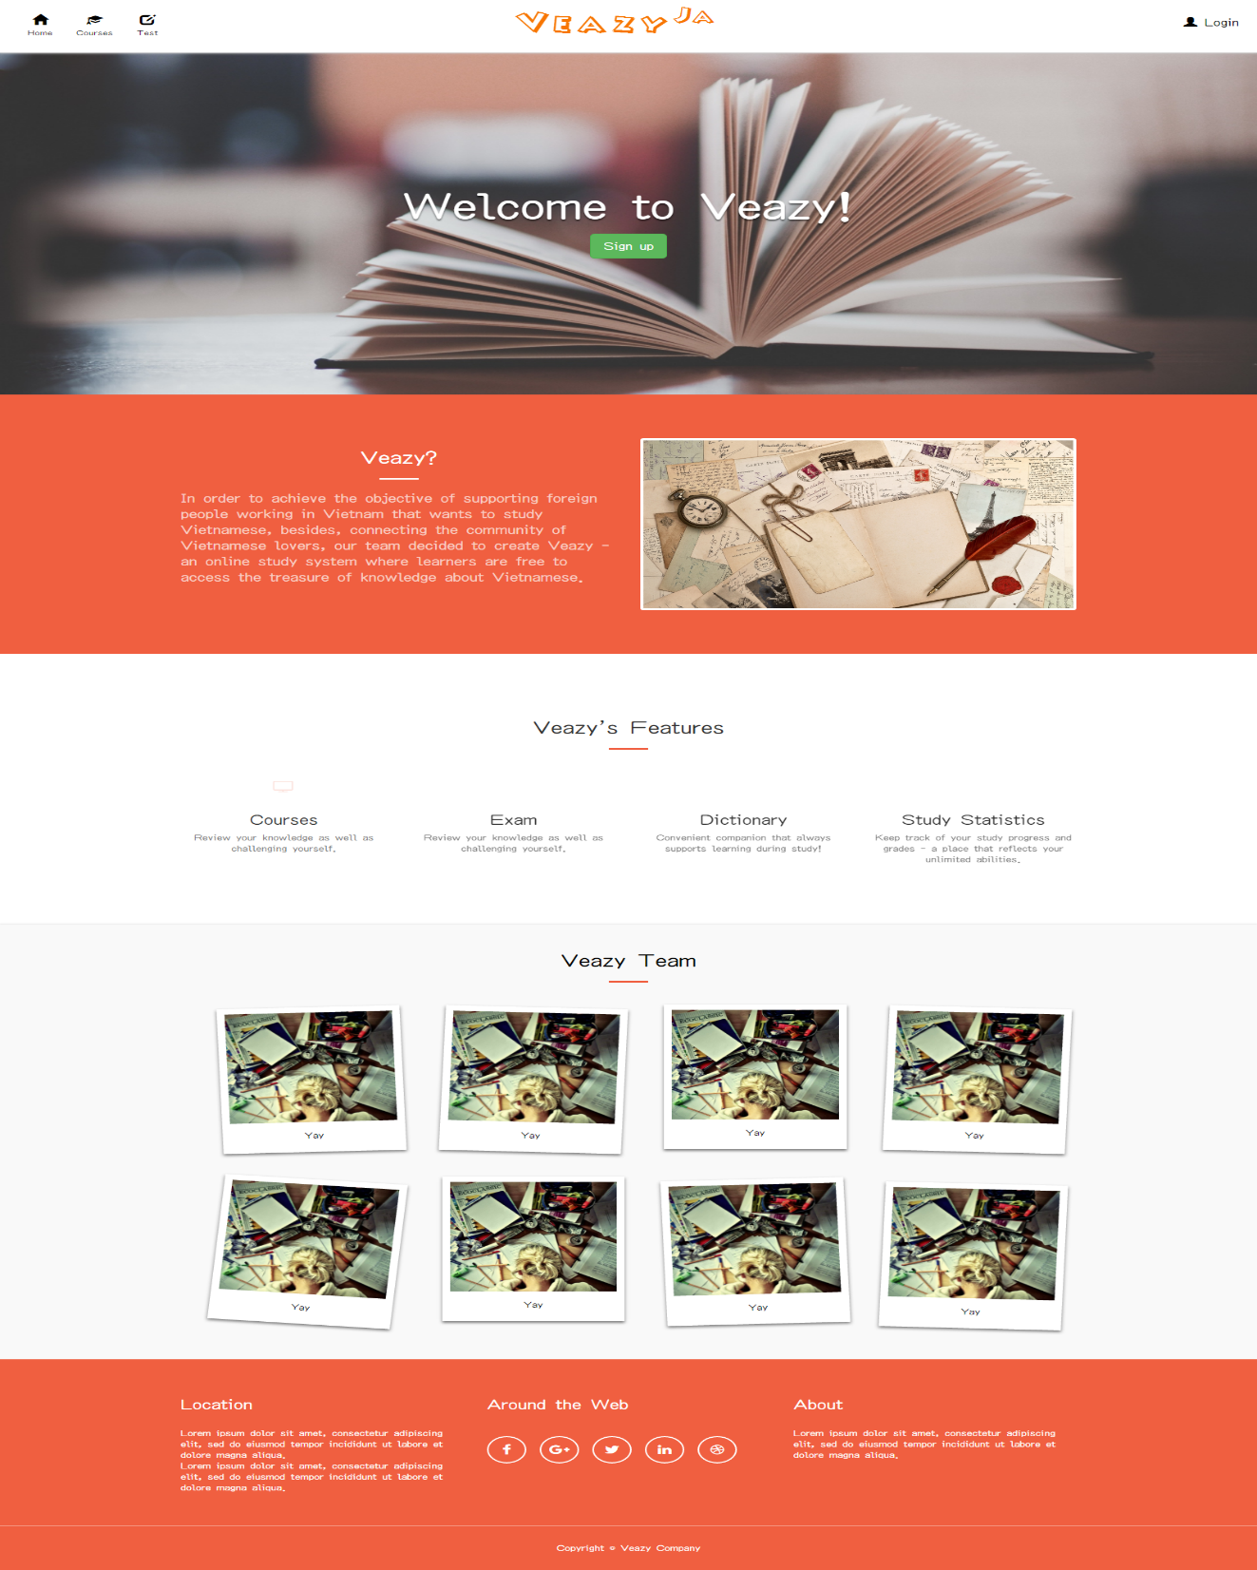

Figure 1 Homepage

# Screen Flow

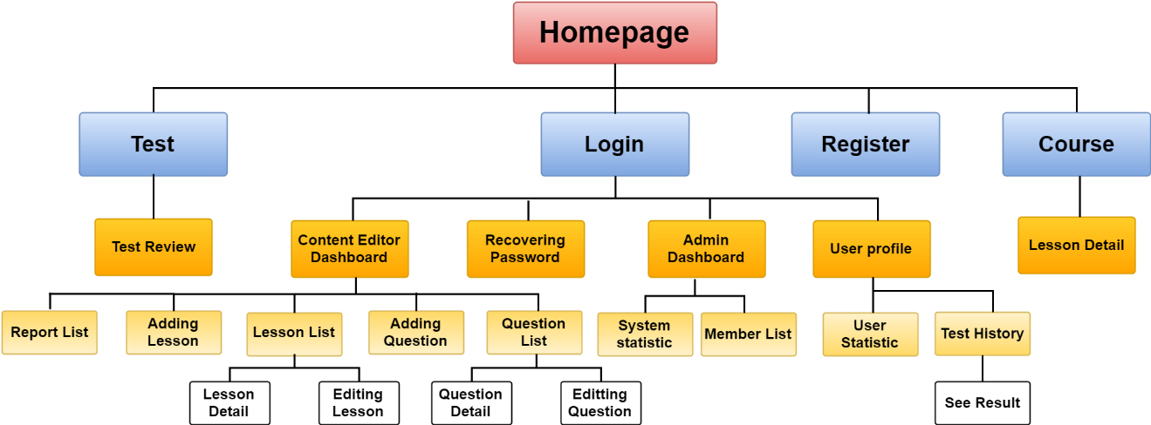

Figure 2. Screen Flow

|  |  |  |
| --- | --- | --- |
| No | Screen Name | Description |
| 1 | Homepage | Homepage |
| 2 | Login | Logging into Veazy system with a registered account |
| 3 | Register | Registering new account |
| 4 | Password Recover | Recovering lost password |
| 5 | Courses | Displaying list of courses and available lessons in each course |
| 6 | Lesson Detail | Displaying lesson content |
| 7 | Test | Setting up test |
| 8 | Test Review | Reviewing test |
| 9 | User Profile | Displaying detailed information of user |
| 10 | User Statistic | Displaying statistics of user |
| 11 | Test History | Displaying list of taken tests |
| 12 | See Result | Displaying content of taken test |
| 13 | Report List | Viewing list report |
| 14 | Lesson List (for content manager & content creator) | Displaying lesson list |
| 15 | Lesson Detail (for content manager & content creator) | Displaying lesson detail |
| 16 | Adding Lesson | Creating new lesson |
| 17 | Editing Lesson | Editing lesson content |
| 18 | Question List | Displaying list of questions intended to be generated in test |
| 19 | Question Detail | Displaying question content |
| 20 | Adding Question | Creating new question |
| 21 | Editing Question | Editing question content |
| 22 | System Statistic | Displaying system statistics |
| 23 | Member List | Displaying list of Veazy members |
| 24 | Test Hítory | Displaying list test history of member |

Table 2. List of screens

## Guest

### Homepage

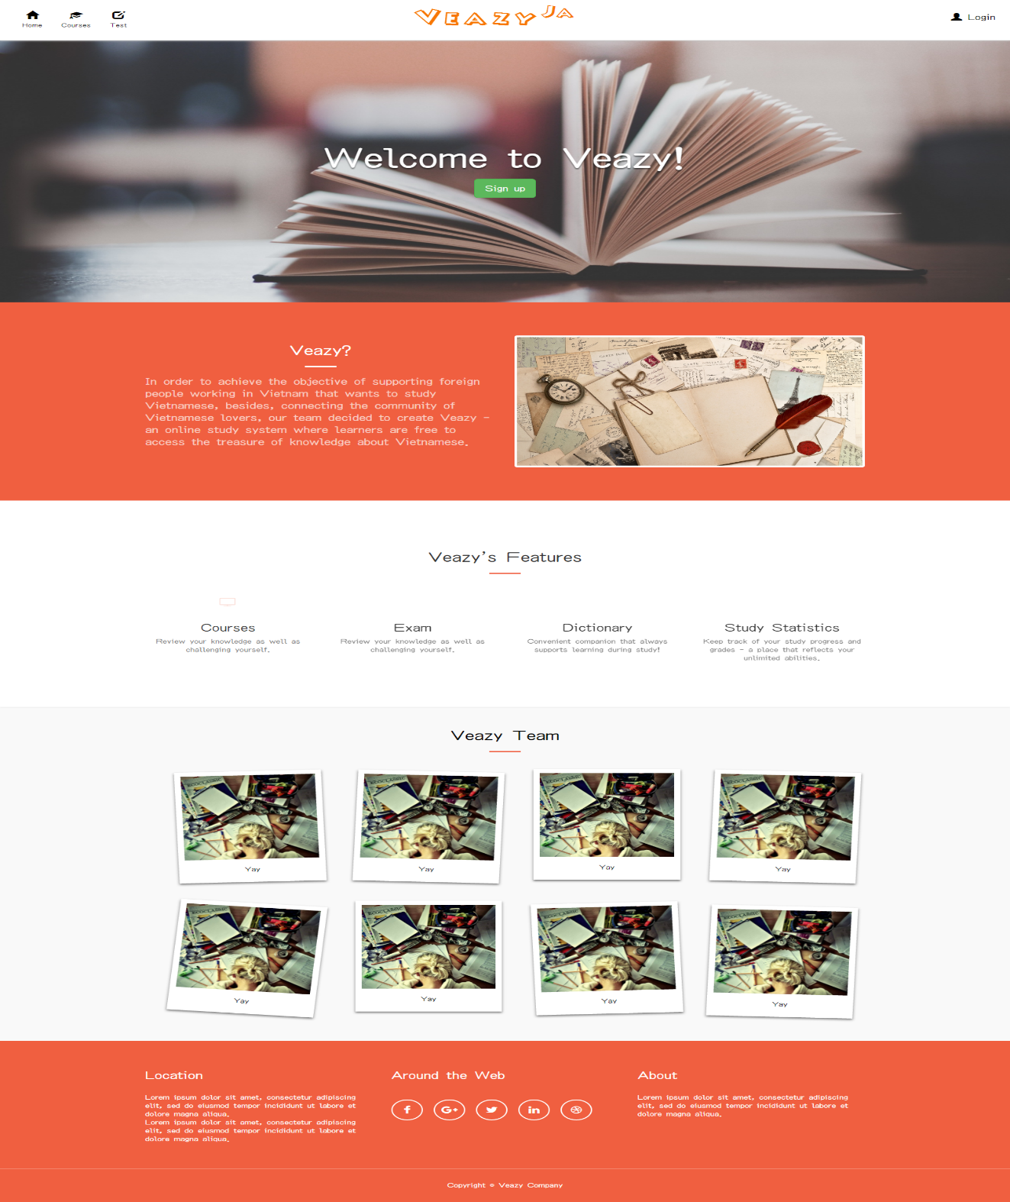

Figure 3. “Home” page

|  |  |  |  |  |  |
| --- | --- | --- | --- | --- | --- |
| **Field name** | **Type** | **Mandatory** | **Min**  **length** | **Max**  **length** | **Description** |
| Veazy | Hyperlink | N |  |  | Hyperlink that change language of website |
| Home | Hyperlink | N |  |  | Hyperlink that redirects to “Home” page |
| Courses | Select box | N |  |  | Select box that redirects to “Courses” page |
| Test | Hyperlink | N |  |  | Hyperlink that redirects to “Test” page |
| Dictionary | Hyperlink | N |  |  | Hyperlink that redirects to “Dictionary” page |
| Login | Hyperlink | N |  |  | Hyperlink that redirects to “Login” page |
| Sign Up | Hyperlink | N |  |  | Button for registering new account |

Table 3. Components of “Home” page

### Login

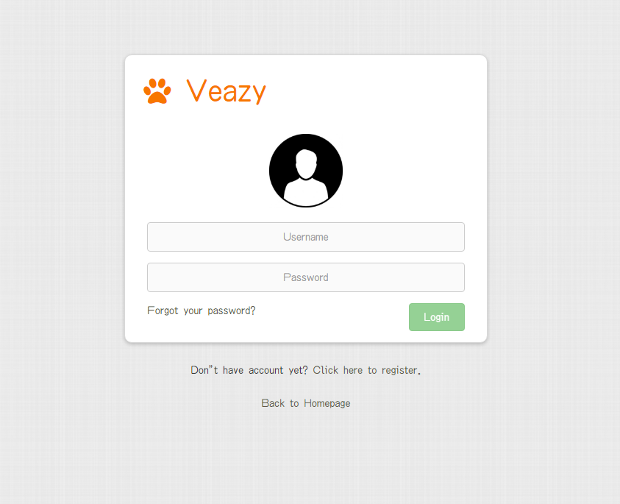

Figure 4. Login page

|  |  |  |  |  |  |
| --- | --- | --- | --- | --- | --- |
| **Field name** | **Type** | **Mandatory** | **Min**  **length** | **Max**  **length** | **Description** |
| Username | Textbox | Y | 6 | 30 | Textbox for entering username |
| Password | Textbox | Y | 6 | 32 | Textbox for entering password |
| Login | Button | Y |  |  | Button for submitting login form |
| Forgot your password? | Hyperlink | N |  |  | Hyperlink that redirects to “Password Recover” page |
| Click here to register. | Hyperlink | N |  |  | Hyperlink that redirects to “Register” page |
| Back to Home | Hyperlink | N |  |  | Hyperlink that redirects to “Home” page |

Table 4. Components of “Login” page

### Password Recover

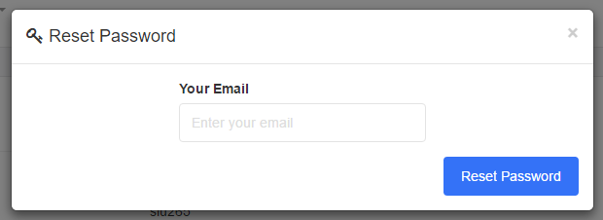

Figure 5. “Password Recover” page

|  |  |  |  |  |  |
| --- | --- | --- | --- | --- | --- |
| **Field name** | **Type** | **Mandatory** | **Min**  **length** | **Max**  **length** | **Description** |
| Email | Textbox | Y | 6 | 254 | Textbox for entering the email linked with current account |
| Reset password | Button | Y |  |  | Button for submitting email |

Table 5. Components of “Password Recover” page

### Register

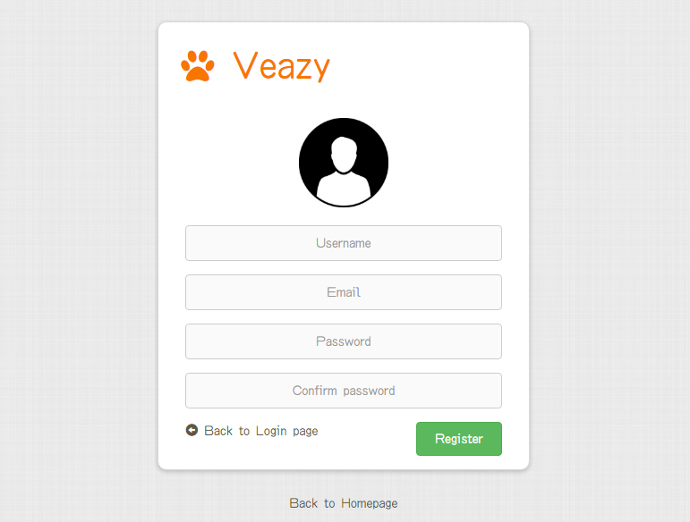

Figure 6. “Register” page

|  |  |  |  |  |  |
| --- | --- | --- | --- | --- | --- |
| **Field name** | **Type** | **Mandatory** | **Min**  **length** | **Max**  **length** | **Description** |
| Username | Textbox | Y | 8 | 30 | Textbox for entering username |
| Email | Textbox | Y | 6 | 254 | Textbox for entering email |
| Password | Textbox | Y | 8 | 32 | Textbox for entering password |
| Confirm Password | Textbox | Y | 8 | 32 | Textbox for re-entering password |
| Register | Button | Y |  |  | Button to submit register form |
| Back to Login page | Hyperlink | N |  |  | Hyperlink that redirects to “Login” page |
| Back to Homepage | Hyperlink | N |  |  | Hyperlink that redirects to “Home” page |

Table 6. Components of “Register” page

### Courses

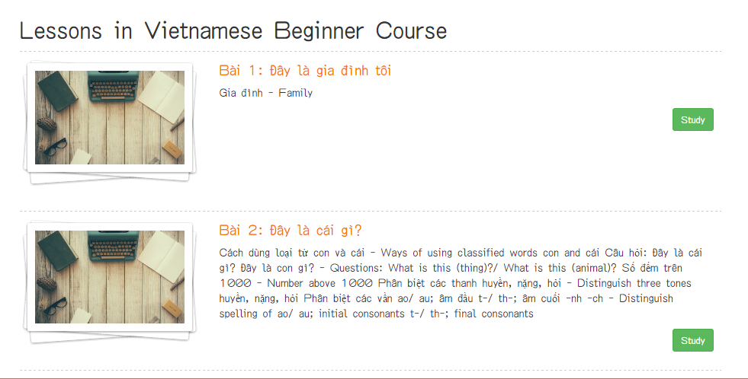

Figure 7. “Courses” page

|  |  |  |  |  |  |
| --- | --- | --- | --- | --- | --- |
| **Field name** | **Type** | **Mandatory** | **Min**  **length** | **Max**  **length** | **Description** |
| Study | Button | N |  |  | Button that redirects to “Lesson” page |

Table 7. Course page’s components

### Lesson

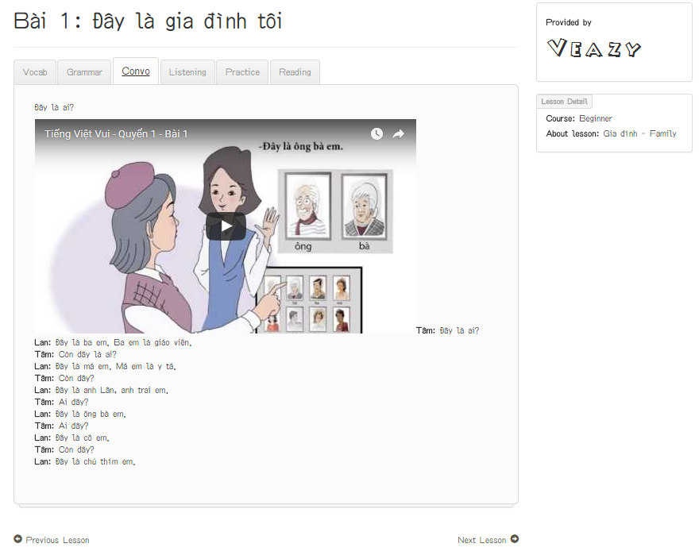

Figure 8. “Lesson Detail” page

|  |  |  |  |  |  |
| --- | --- | --- | --- | --- | --- |
| **Field name** | **Type** | **Mandatory** | **Min**  **length** | **Max**  **length** | **Description** |
| Vocab | Hyperlink | N |  |  | Hyperlink that displays content of Vocabulary section |
| Grammar | Hyperlink | N |  |  | Hyperlink that displays content of Grammar section |
| Convo | Hyperlink | N |  |  | Hyperlink that displays content of Conversation section |
| Listening | Hyperlink | N |  |  | Hyperlink that displays content of Listening section |
| Practice | Hyperlink | N |  |  | Hyperlink that displays content of Practice section |
| Reading | Hyperlink | N |  |  | Hyperlink that displays content of Reading section |
| Previous lesson | Hyperlink | N |  |  | Hyperlink that redirects to “Lesson” page which displays content of the previous lesson |
| Next lesson | Hyperlink | N |  |  | Hyperlink that redirects to “Lesson” page which displays content of the next lesson |
| Report | Hyperlink | N |  |  | Hyperlink to display lesson report dialog |

Table 8. Components of “Lesson” page

### Test

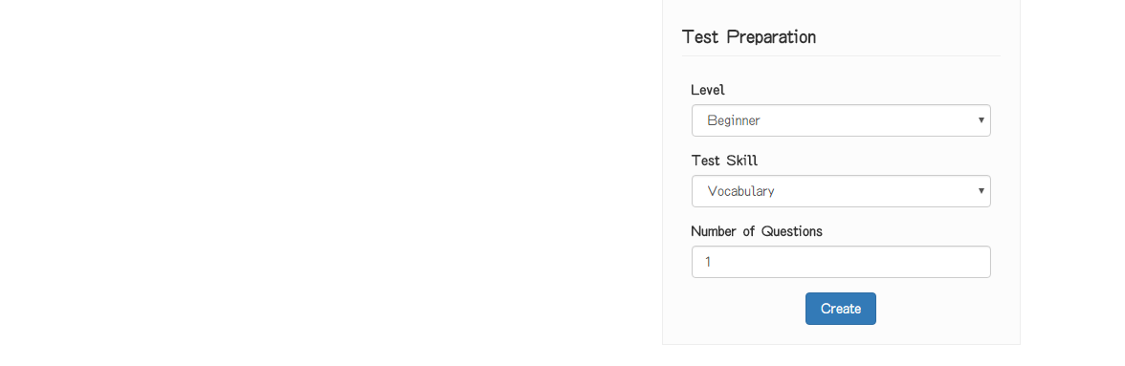

Figure 9. “Test” page

|  |  |  |  |  |  |
| --- | --- | --- | --- | --- | --- |
| **Field name** | **Type** | **Mandatory** | **Min**  **length** | **Max**  **length** | **Description** |
| Level | Select box | Y |  |  | Select box for selecting difficulty level of test |
| Test Skill | Select box | Y |  |  | Select box for selecting skill to be tested |
| Question Limit | Number | Y |  |  | Textbox for entering the number of questions |
| Create | Button | Y |  |  | Button for submitting test setup form and redirecting to “Take Test” page |

Table 9. Components of “Test” page

### Taking Test

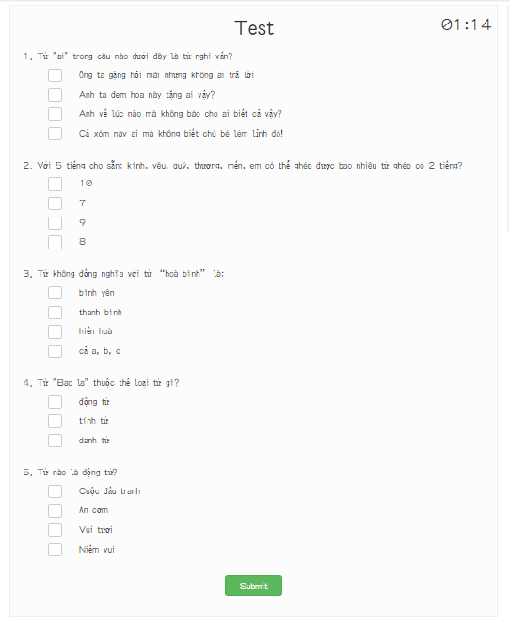

Figure 10. “Taking Test” page

|  |  |  |  |  |  |
| --- | --- | --- | --- | --- | --- |
| **Field name** | **Require** | **Mandatory** | **Min**  **length** | **Max**  **length** | **Description** |
| Answer | Click | Y |  |  | Radio button for choosing the correct answer |
| Submit | Click | Y |  |  | Button for submitting the test and redirecting to “Test Result” page |

Table 10. Components of “Taking Test” page

### Test Result

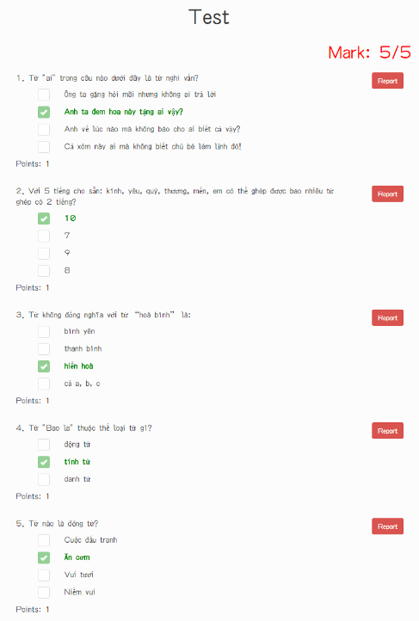

Figure 11. “Test Result” page

|  |  |  |  |  |  |
| --- | --- | --- | --- | --- | --- |
| **Field name** | **Type** | **Mandatory** | **Min**  **length** | **Max**  **length** | **Description** |
| Report | Button | Y |  |  | Button for submitting report about questions that user subjectively consider wrong content. |

Table 11. Components of “Test Result” page

## Logged-in user

### User Profile

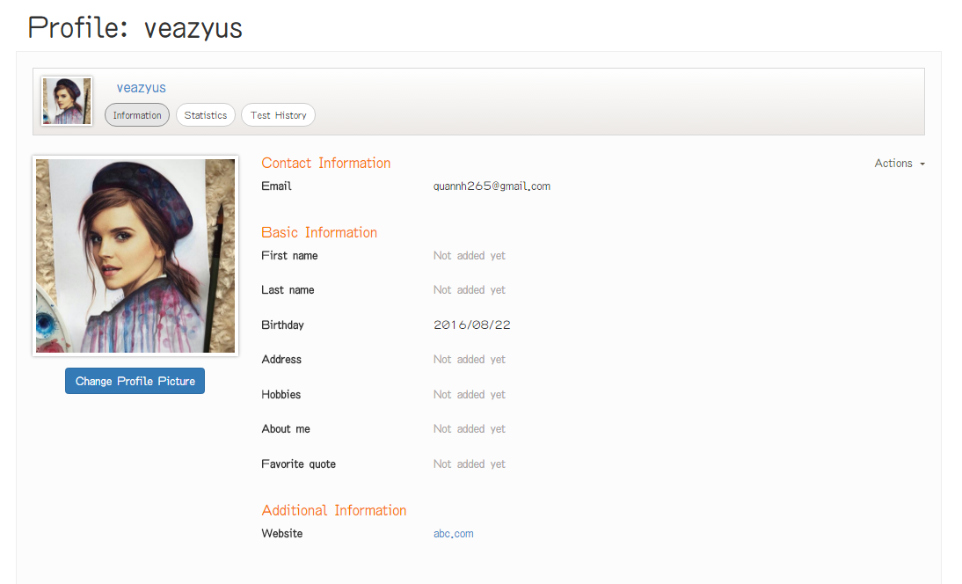

Figure 12. “User Profile” page

|  |  |  |  |  |  |
| --- | --- | --- | --- | --- | --- |
| **Field name** | **Type** | **Mandatory** | **Min**  **length** | **Max**  **length** | **Description** |
| Action | Dropdown | N |  |  | Dropdown that displays selectable options for user include editing information and changing current password |
| Information | Button | N |  |  | Button for displaying tab for viewing user information |
| Change Avatar Picture | Button | N |  |  | Button for displaying dialog for changing current avatar picture |
| Statistic | Button | N |  |  | Button for displaying tab for viewing user statistics |
| Test History | Button | N |  |  | Button for displaying tab for test history user statistics |

Table 12. Components of “User Profile” page

### User Statistic

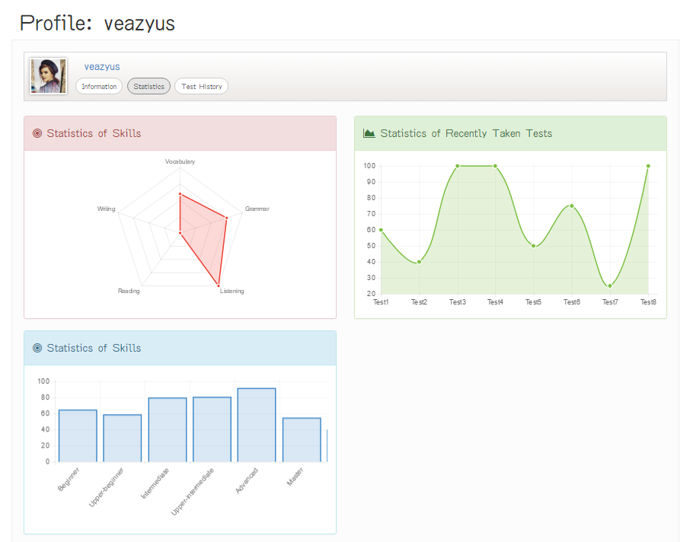

Figure 13. “User Statistic” page

|  |  |  |  |  |  |
| --- | --- | --- | --- | --- | --- |
| **Field name** | **Type** | **Mandatory** | **Min**  **length** | **Max**  **length** | **Description** |
| Information | Button | N |  |  | Button for displaying tab for viewing user information |
| Statistic | Button | N |  |  | Button for displaying tab for viewing user statistics |
| Test History | Button | N |  |  | Button for displaying tab for test history user statistics |

Table 13. Components of “User Statistic” page

### Test History

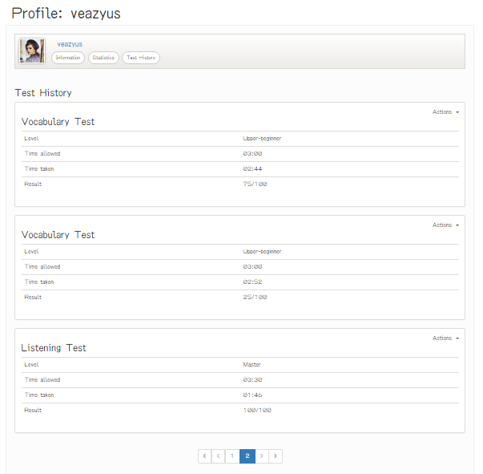

Figure 14. “Test History” page

|  |  |  |  |  |  |
| --- | --- | --- | --- | --- | --- |
| **Field name** | **Type** | **Mandatory** | **Min**  **length** | **Max**  **length** | **Description** |
| Information | Button | N |  |  | Button for displaying tab for viewing user information |
| Statistic | Button | N |  |  | Button for displaying tab for viewing user statistics |
| Test History | Button | N |  |  | Button for displaying tab for test history user statistics |
| Actions | Dropdown | N |  |  | Dropdown that displays selectable options for user include seeing result and retaking test |
| << | Button | N |  |  | Button for displaying the first 5 taken tests in table |
| < | Button | N |  |  | Button for navigating to 5 previous taken tests in table |
| > | Button | N |  |  | Button for navigating to 5 next taken tests in table |
| >> | Button | N |  |  | Button for navigating to 5 last taken tests in table |

Table 14. Components of “Test History” page

### See Result

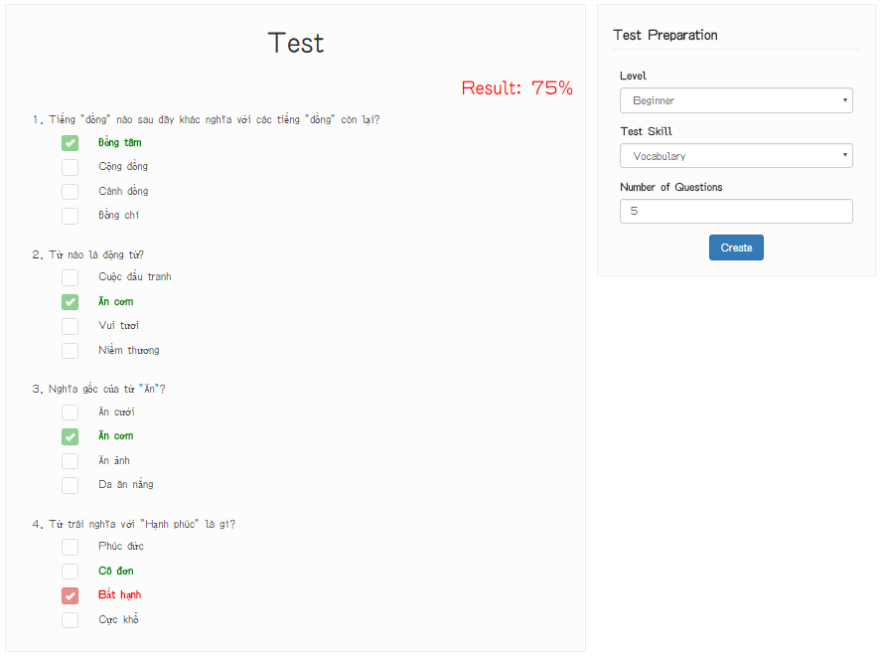

Figure 15. “See Result” page

|  |  |  |  |  |  |
| --- | --- | --- | --- | --- | --- |
| **Field name** | **Type** | **Mandatory** | **Min**  **length** | **Max**  **length** | **Description** |
| Level | Select box | Y |  |  | Select box for selecting difficulty level of test |
| Test Skill | Select box | Y |  |  | Select box for selecting skill to be tested |
| Question Limit | Number | Y |  |  | Textbox for entering the number of questions |
| Create | Button | Y |  |  | Button for submitting test setup form and redirecting to “Take Test” page |

Table 15. Components of “See Result” page

## Content creator

### Content Creator Dashboard

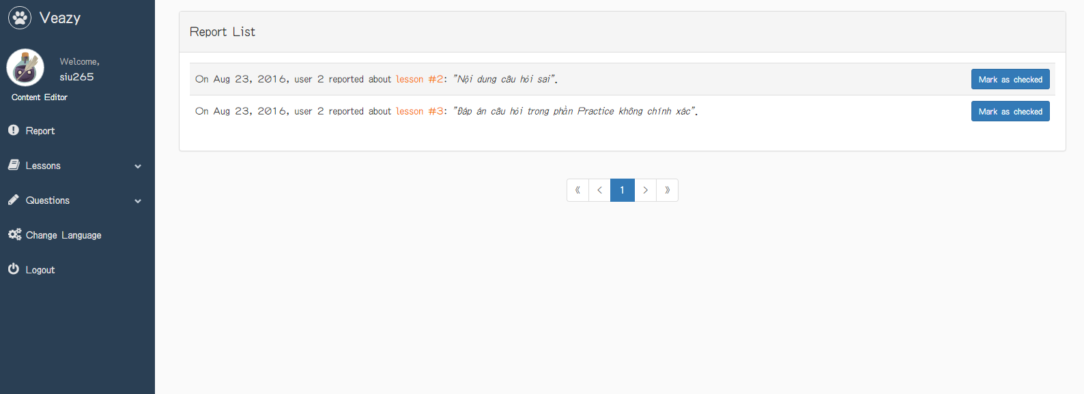

Figure 16. “Content Creator Dashboard” page

|  |  |  |  |  |  |
| --- | --- | --- | --- | --- | --- |
| **Field name** | **Type** | **Mandatory** | **Min**  **length** | **Max**  **length** | **Description** |
| Lessons | Hyperlink | N |  |  | Hyperlink that opens lesson management menu |
| Lesson List | Hyperlink | N |  |  | Hyperlink that redirects to “Lesson List” page |
| Add Lesson | Hyperlink | N |  |  | Hyperlink that redirects to “Adding Lesson” page |
| Question | Hyperlink | N |  |  | Hyperlink that opens question management menu |
| Question List | Hyperlink | N |  |  | Hyperlink that redirects to “Question List” page |
| Add Question | Hyperlink | N |  |  | Hyperlink that redirects to “Adding Question” page |
| Reports | Hyperlink | N |  |  | Hyperlink that redirects to “Report List” page |
| Logout | Hyperlink | N |  |  | Hyperlink that logs user out of Veazy system |
| << | Button | N |  |  | Button for displaying the first 5 reports in table |
| < | Button | N |  |  | Button for navigating to 5 previous reports in table |
| > | Button | N |  |  | Button for navigating to 5 next reports in table |
| >> | Button | N |  |  | Button for navigating to 5 last taken tests in table |
| Mark as checked | Button | N |  |  | Button for marking checked report |

Figure 16. Components of “Content Creator Dashboard”

### Lesson List

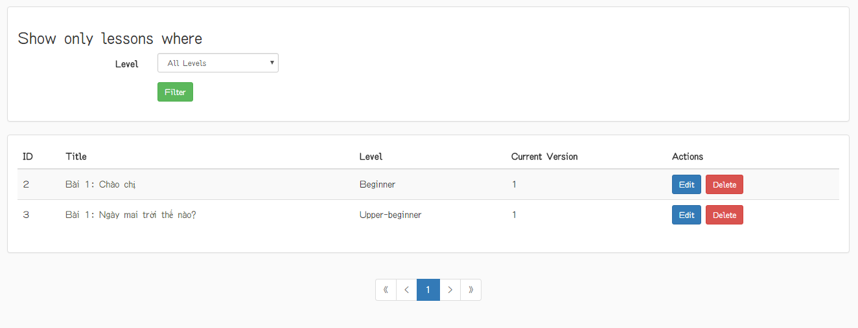

Figure 17. “Lesson List” page

|  |  |  |  |  |  |
| --- | --- | --- | --- | --- | --- |
| **Field name** | **Type** | **Mandatory** | **Min**  **length** | **Max**  **length** | **Description** |
| Lesson title | Hyperlink | N |  |  | Hyperlink that redirects to “Lesson Detail” page |
| Edit | Button | N |  |  | Hyperlink that redirects to “Editing Lesson” page |
| Delete | Button | N |  |  | Button for deleting corresponding lesson |
| << | Button | N |  |  | Button for displaying the first 5 lessons in table |
| < | Button | N |  |  | Button for navigating to 5 previous lessons in table |
| > | Button | N |  |  | Button for navigating to 5 next lessons in table |
| >> | Button | N |  |  | Button for navigating to 5 last lessons in table |
| Level | Dropdown | N |  |  | Dropdown that displays selectable options for user selects level of lesson |
| Filter | Button | N |  |  | Button for filtering level of lesson |

Figure 17. Components of “Lesson List”

### Lesson Detail

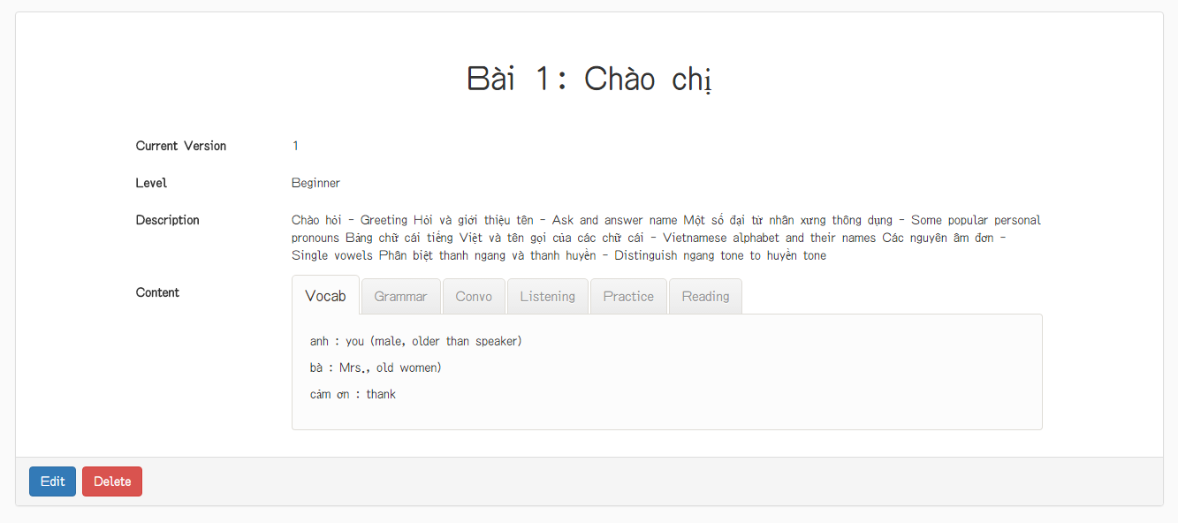

Figure 18. “Lesson List” page

|  |  |  |  |  |  |
| --- | --- | --- | --- | --- | --- |
| **Field name** | **Type** | **Mandatory** | **Min**  **length** | **Max**  **length** | **Description** |
| Vocab | Hyperlink | N |  |  | Hyperlink that displays content of Vocabulary section |
| Grammar | Hyperlink | N |  |  | Hyperlink that displays content of Grammar section |
| Convo | Hyperlink | N |  |  | Hyperlink that displays content of Conversation section |
| Listening | Hyperlink | N |  |  | Hyperlink that displays content of Listening section |
| Practice | Hyperlink | N |  |  | Hyperlink that displays content of Practice section |
| Reading | Hyperlink | N |  |  | Hyperlink that displays content of Reading section |
| Edit | Button | N |  |  | Hyperlink that redirects to “Editing Lesson” page |
| Delete | Button | N |  |  | Button for deleting corresponding lesson |

Figure 18. Components of “Lesson Detail”

### Adding Lesson

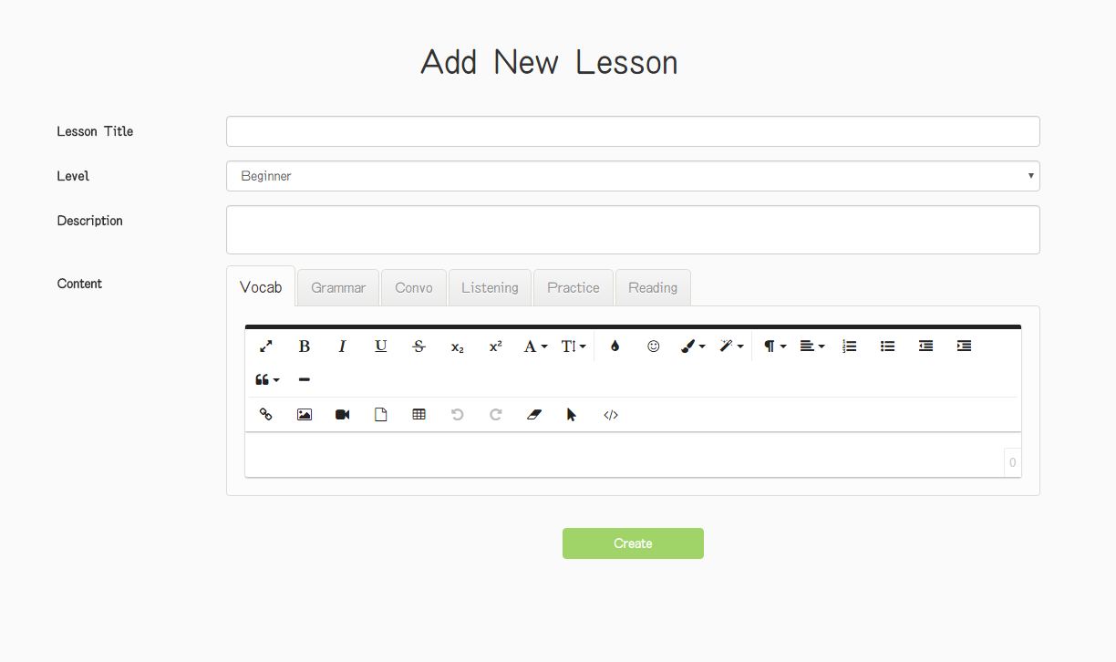

Figure 19. “Adding Lesson” page

|  |  |  |  |  |  |
| --- | --- | --- | --- | --- | --- |
| **Field name** | **Type** | **Mandatory** | **Min**  **length** | **Max**  **length** | **Description** |
| Lesson Title | Text | Y | 0 |  | Textbox for entering lesson title |
| Level | Select box | Y |  |  | Select box for choosing difficulty level of lesson |
| Description | Text area | Y |  |  | Text area for entering lesson description |
| Vocab | Hyperlink | Y |  |  | Hyperlink that displays editor of Vocabulary section |
| Text area | Y |  |  | Text area for entering content of Vocabulary section |
| Grammar | Hyperlink | Y |  |  | Hyperlink that displays editor of Grammar section |
| Text area | Y |  |  | Text area for entering content of Grammar section |
| Convo | Hyperlink | Y |  |  | Hyperlink that displays editor of Conversation section |
| Text area | Y |  |  | Text area for entering content of Conversation section |
| Listening | Hyperlink | Y |  |  | Hyperlink that displays editor of Listening section |
| Text area | Y |  |  | Text area for entering content of Listening section |
| Practice | Hyperlink | Y |  |  | Hyperlink that displays editor of Practice section |
| Text area | Y |  |  | Text area for entering content of Practice section |
| Reading | Hyperlink | Y |  |  | Hyperlink that displays editor of Reading section |
| Text area | Y |  |  | Text area for entering content of Reading section |
| Create | Button | Y |  |  | Button for submitting new lesson |

Table 19. Components of “Adding Lesson” page

### Editing Lesson

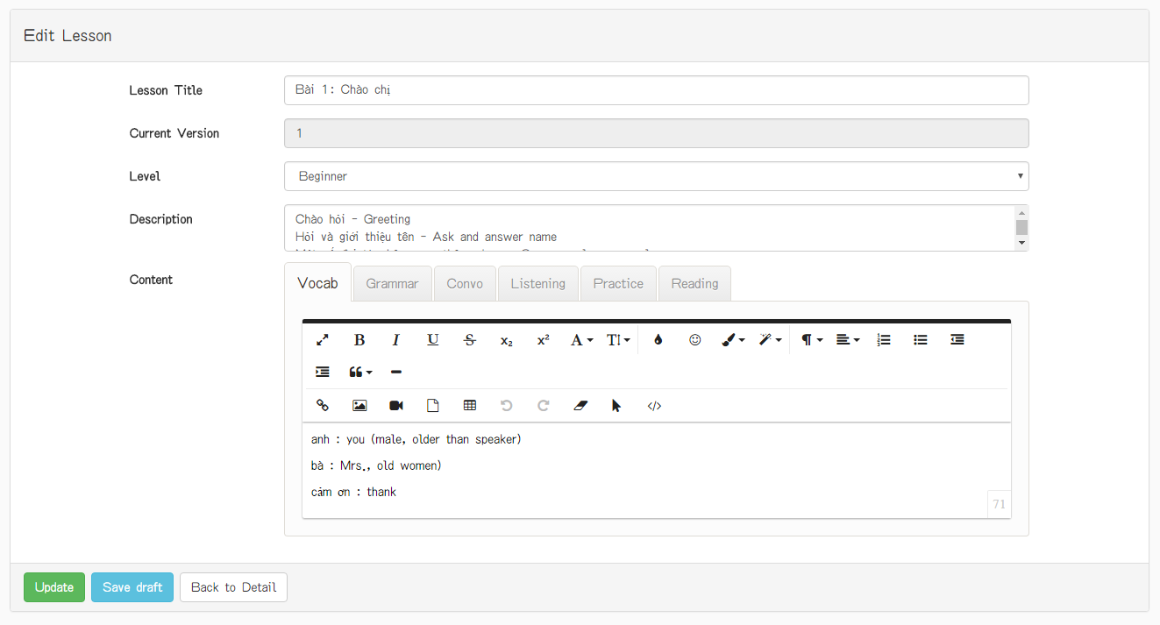

Figure 20. “Editing Lesson” page

|  |  |  |  |  |  |
| --- | --- | --- | --- | --- | --- |
| **Field name** | **Type** | **Mandatory** | **Min**  **length** | **Max**  **length** | **Description** |
| Lesson Title | Text | Y |  |  | Textbox for entering lesson title |
| Level | Select box | Y |  |  | Select box for choosing difficulty level of lesson |
| Description | Text area | Y |  |  | Text area for entering lesson description |
| Vocab | Hyperlink | Y |  |  | Hyperlink that displays editor of Vocabulary section |
| Text area | Y |  |  | Text area for entering content of Vocabulary section |
| Grammar | Hyperlink | Y |  |  | Hyperlink that displays editor of Grammar section |
| Text area | Y |  |  | Text area for entering content of Grammar section |
| Convo | Hyperlink | Y |  |  | Hyperlink that displays editor of Conversation section |
| Text area | Y |  |  | Text area for entering content of Conversation section |
| Listening | Hyperlink | Y |  |  | Hyperlink that displays editor of Listening section |
| Text area | Y |  |  | Text area for entering content of Listening section |
| Practice | Hyperlink | Y |  |  | Hyperlink that displays editor of Practice section |
| Text area | Y |  |  | Text area for entering content of Practice section |
| Reading | Hyperlink | Y |  |  | Hyperlink that displays editor of Reading section |
| Text area | Y |  |  | Text area for entering content of Reading section |
| Create | Button | Y |  |  | Button for submitting new lesson |
| Save Draft | Button | Y |  |  | Button for saving lesson |
| Back to Detail | Button | Y |  |  | Button for backing to detail of lesson page |

Table 20. Components of “Editting Lesson” page

### Question List

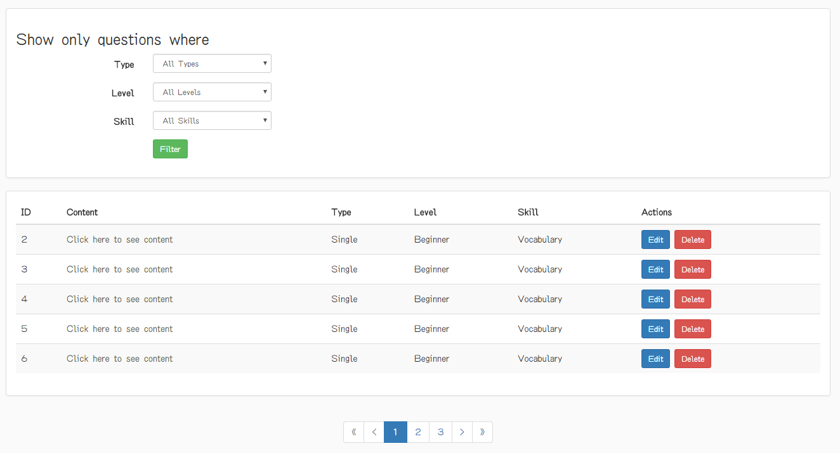

Figure 21. “Question List” page

|  |  |  |  |  |  |
| --- | --- | --- | --- | --- | --- |
| **Field name** | **Type** | **Mandatory** | **Min**  **length** | **Max**  **length** | **Description** |
| Click here to see content | Hyperlink | N |  |  | Hyperlink that redirects to “Question Detail” page |
| Edit | Button | N |  |  | Hyperlink that redirects to “Editing Question” page |
| Delete | Button | N |  |  | Button for deleting corresponding question |
| First | Button | N |  |  | Button for displaying the first 5 questions in table |
| Previous | Button | N |  |  | Button for navigating to 5 previous questions in table |
| Next | Button | N |  |  | Button for navigating to 5 next records in table |
| Last | Button | N |  |  | Button for navigating to 5 last questions in table |
| Type | Dropdown | N |  |  | Dropdown that displays selectable options for user selects type of question |
| Level | Dropdown | N |  |  | Dropdown that displays selectable options for user selects level of question |
| Skill | Dropdown | N |  |  | Dropdown that displays selectable options for user selects skill of question |
| Filter | Button | N |  |  | Button for filtering question |

Table 21. Components of “Question List page

### Question Detail

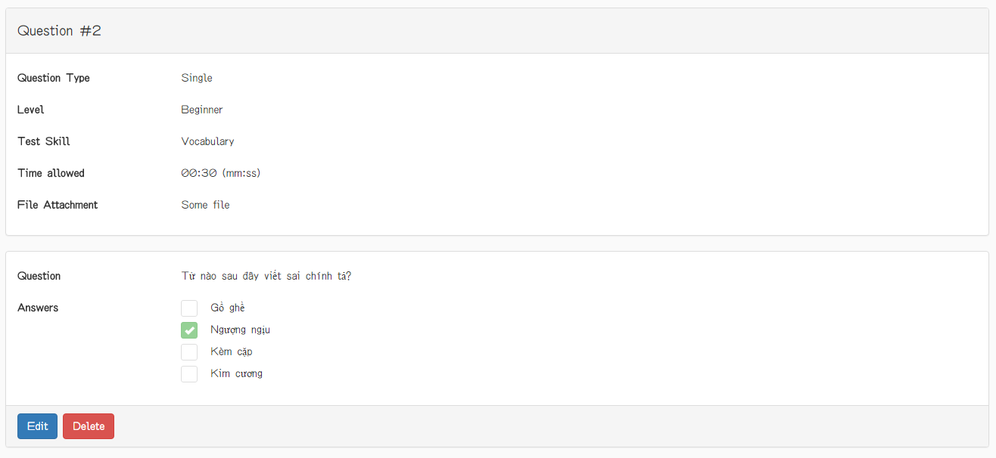

Figure 22. “Question Detail” page (single question)

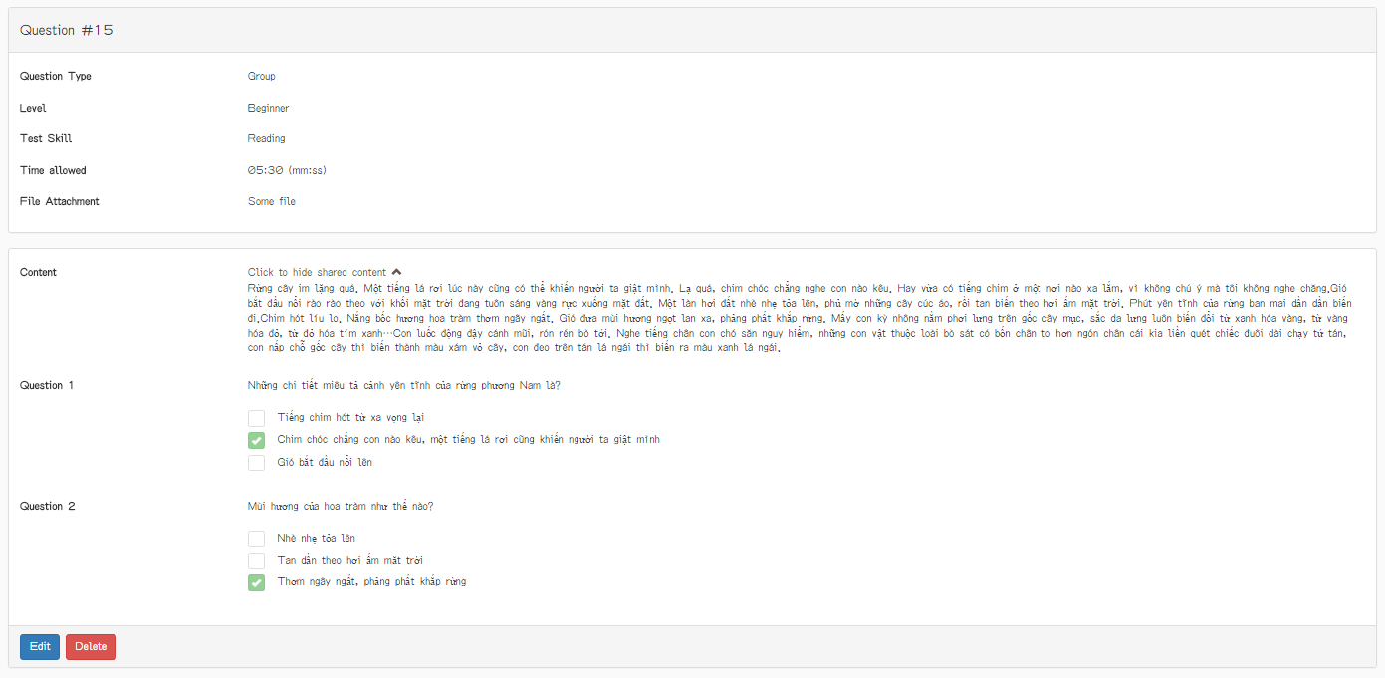

Figure 23. “Question Detail” page (group question)

|  |  |  |  |  |  |
| --- | --- | --- | --- | --- | --- |
| **Field name** | **Type** | **Mandatory** | **Min**  **length** | **Max**  **length** | **Description** |
| Click to show shared content | Hyperlink |  |  |  | Hyperlink that displays shared content of group question |
| Edit | Button | N |  |  | Button that redirects to “Editing Question” page |
| Delete | Button | N |  |  | Button for deleting question |

Table 22. Components of “Question Detail” page

### Adding Question

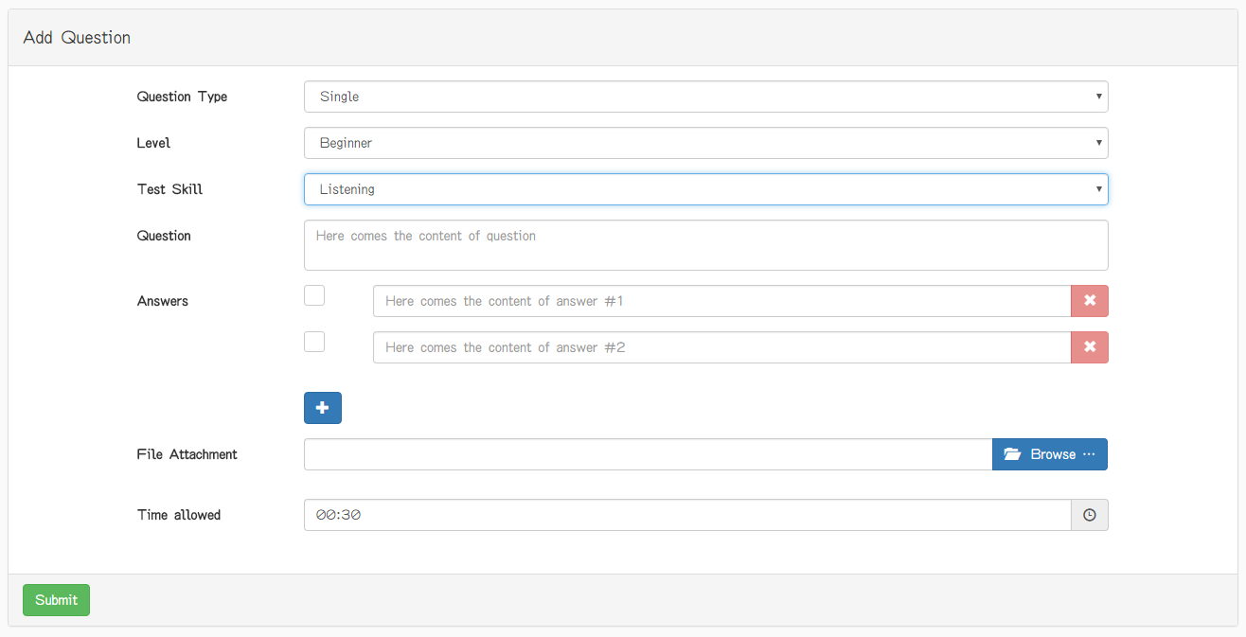

Figure 24. “Adding Question” page (single question)

|  |  |  |  |  |  |
| --- | --- | --- | --- | --- | --- |
| **Field name** | **Type** | **Mandatory** | **Min**  **length** | **Max**  **length** | **Description** |
| Question type | Select box | Y |  |  | Select box for choosing type of question |
| Level | Select box | Y |  |  | Select box for choosing difficulty level of question |
| Test Skill | Select box | Y |  |  | Select box for choosing skill to be tested of question |
| Question | Text | Y |  |  | Textbox for entering question |
| Check box | Check box | Y |  |  | Checkbox for marking which answer is true |
| Answer | Text | Y |  |  | Textbox for entering answer content |
| X | Button | N |  |  | Button for removing an answer |
| + | Button | N |  |  | Button for adding one more answer to the question |
| Browser | File | N |  |  | Button for display dialog of selection audio |
| Submit | Button | Y |  |  | Button for submitting new question |
| Time Allowed | Textbox | N |  |  | Textbox for displaying time of question |
| Clock | Icon | N |  |  | Textbox for setting time of question |

Table 23. Components of “Adding Question” page (single question)

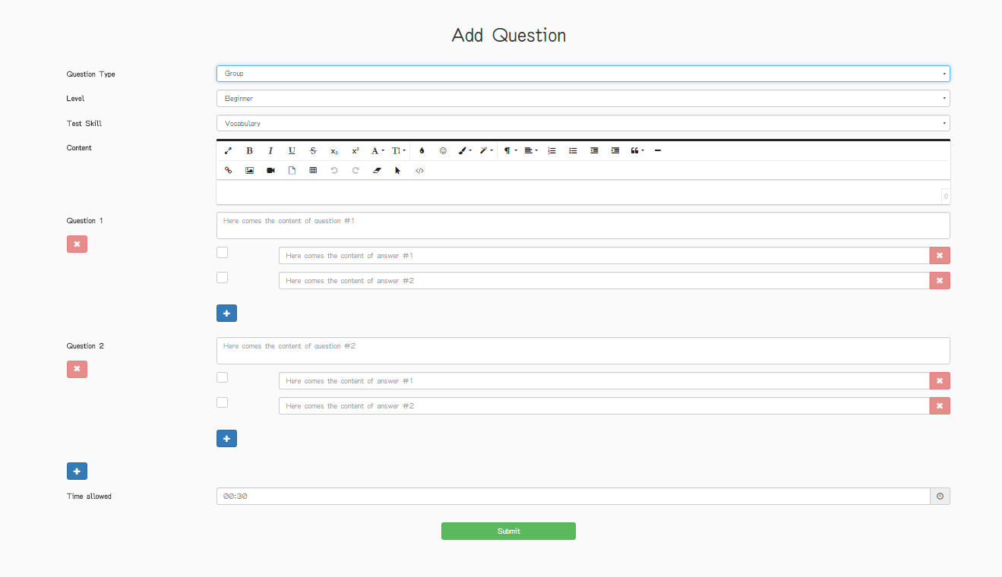

Figure 25. “Adding Question” page (group question)

|  |  |  |  |  |  |
| --- | --- | --- | --- | --- | --- |
| **Field name** | **Type** | **Mandatory** | **Min**  **length** | **Max**  **length** | **Description** |
| Question type | Select box | Y |  |  | Select box for choosing type of question |
| Level | Select box | Y |  |  | Select box for choosing difficulty level of question |
| Test Skill | Select box | Y |  |  | Select box for choosing skill to be tested of question |
| Content | Text area | Y |  |  | Text area for entering shared content of group question |
| Question | Textbox | Y |  |  | Textbox for entering content of question in group |
| X | Button | N |  |  | Button for removing question in group |
| Check box | Check box | Y |  |  | Checkbox that marks the correct answer in question |
| Answer | Textbox | Y |  |  | Textbox for entering content of answer |
| X | Button | Y |  |  | Button for removing answer in question |
| + | Button | N |  |  | Button for adding one more answer |
| + | Button | N |  |  | Button for adding one more question |
| Submit | Button | Y |  |  | Button for submitting new question |
| Time Allowed | Textbox | Y |  |  | Textbox for setting time of question |

Table 24. Components of “Adding Question” page (group question)

### Editing Question

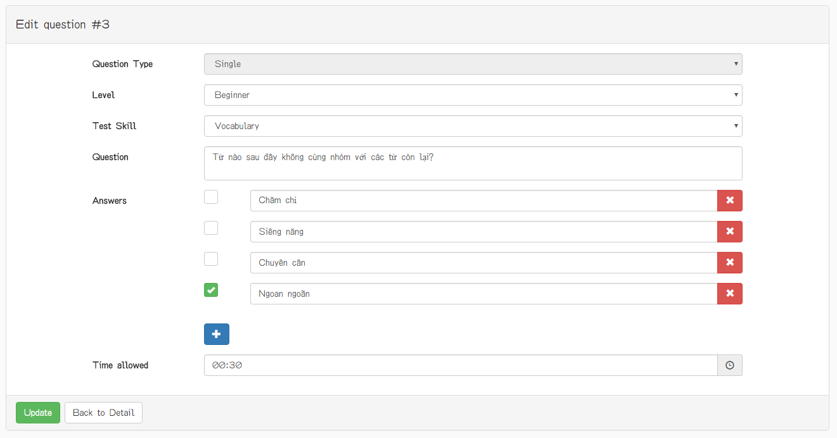

Figure 26. “Editing Question” page (single question) (1)

|  |  |  |  |  |  |
| --- | --- | --- | --- | --- | --- |
| **Field name** | **Type** | **Mandatory** | **Min**  **length** | **Max**  **length** | **Description** |
| Question type | Select box | Y |  |  | Select box for choosing type of question |
| Level | Select box | Y |  |  | Select box for choosing difficulty level of question |
| Test Skill | Select box | Y |  |  | Select box for choosing skill to be tested of question |
| Question | Textbox | Y |  |  | Textbox for entering content of question in group |
| Check box | Check box | Y |  |  | Checkbox that marks the correct answer in question |
| Answer | Textbox | Y |  |  | Textbox for entering content of answer |
| + | Button | N |  |  | Button for adding more selectable answers of the question |
| X | Button | N |  |  | Button for deleting answer of question |
| Submit | Button | Y |  |  | Button for submiting the question content |
| Back to Detail | Button | Y |  |  | Button for backing to Question Detail page |
| Time Allowed | Textbox | N |  |  | Textbox for displaying time of question |
| Clock | Icon | N |  |  | Textbox for setting time of question |

Table 25. Components of “Editing Question” page (single question) (1)

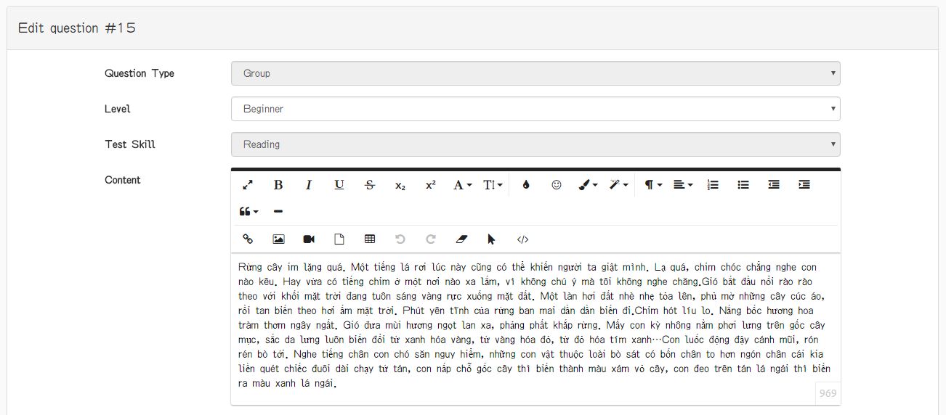

Figure 27. “Editing Question” page (group question) (2)

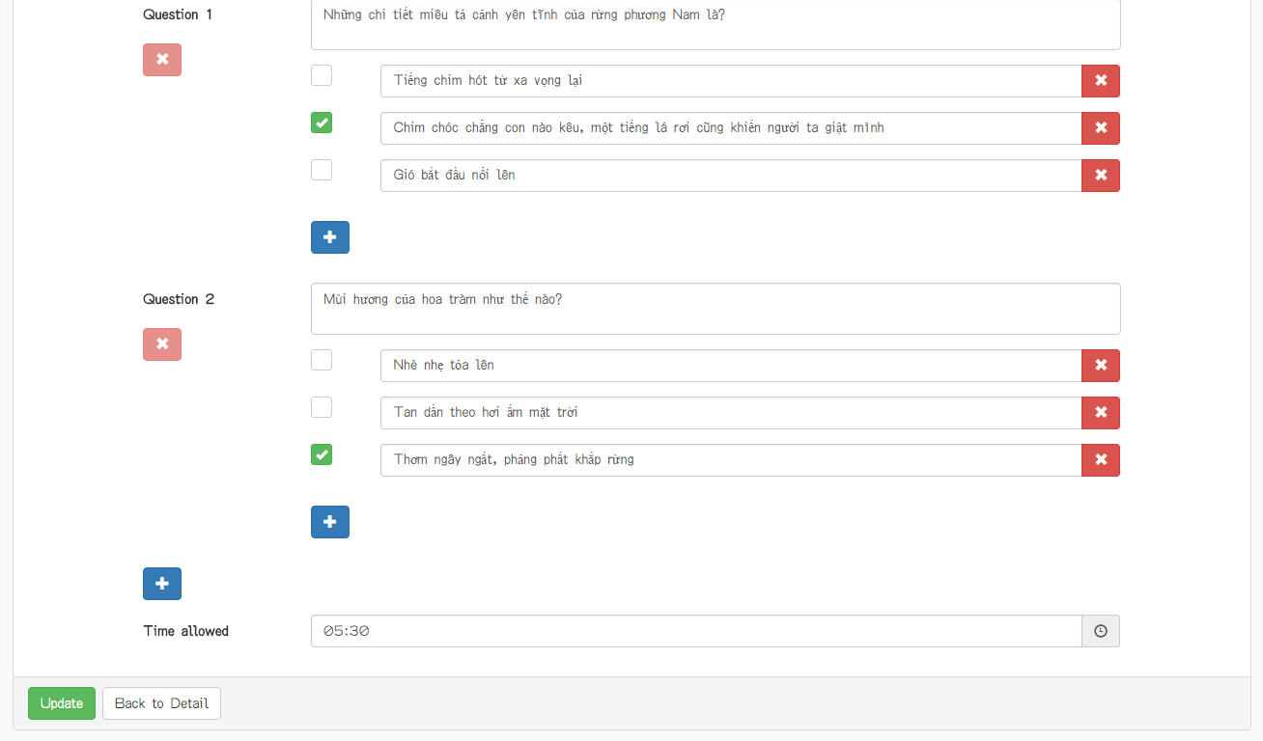

Figure 28. “Editing Question” page (group question) (3)

|  |  |  |  |  |  |
| --- | --- | --- | --- | --- | --- |
| **Field name** | **Type** | **Mandatory** | **Min**  **length** | **Max**  **length** | **Description** |
| Question type | Select box | Y |  |  | Select box for choosing type of question |
| Level | Select box | Y |  |  | Select box for choosing difficulty level of question |
| Test Skill | Select box | Y |  |  | Select box for choosing skill to be tested of question |
| Content | Text | Y |  |  | Textarea for entering the shared content used by all questions |
| Question | Text | Y |  |  | Textarea for entering content of a single question in group |
| X | Button | N |  |  | Button for deleting the corresponding question in group |
| Check box | Check box | Y |  |  | Checkbox that marks the correct answer in question |
| Answer | Text | Y |  |  | Textbox for entering content of answer |
| X | Button | Y |  |  | Button for deleting the corresponding answer |
| + | Button | N |  |  | Button for adding more question to the group |
| + | Button | N |  |  | Button for adding more answer to the question |
| Submit | Button | Y |  |  | Button for submitting the group question |
| Back to Detail | Button | Y |  |  | Button for backing to Question Detail page |
| Time Allowed | Textbox | N |  |  | Textbox for displaying time of question |
| Clock | Icon | N |  |  | Textbox for setting time of question |

Table 26. Components of “Editing Question” page (group question)(2)

## Admin

### Admin Dashboard

Figure 29. “Admin Dashboard” page

|  |  |  |  |  |  |
| --- | --- | --- | --- | --- | --- |
| **Field name** | **Type** | **Mandatory** | **Min**  **length** | **Max**  **length** | **Description** |
|  |  |  |  |  |  |
|  |  |  |  |  |  |

Table 27. Components of “Admin Dashboard” page

### Member List

Figure 30. “Member List” page

|  |  |  |  |  |  |
| --- | --- | --- | --- | --- | --- |
| **Field name** | **Type** | **Mandatory** | **Min**  **length** | **Max**  **length** | **Description** |
|  |  |  |  |  |  |
|  |  |  |  |  |  |
|  |  |  |  |  |  |
|  |  |  |  |  |  |
|  |  |  |  |  |  |

Table 28. Components of “Member List” page

# Other considerations

**N/A**